**Assignment 24.6**

Problem Statement

1.Write a hive query to find the minimum temperature observed in a given weather station in a particular year.

2. Write a hive query to find the maximum temperature observed in a given weather station in a particular year.

3. Write a hive query to find the number of readings given by each weather station according to the dataset.

Data Definition: Column 1: Weather Station Column 2: Date(year/Month/Day) Column 3: Observation Type Column 4: Temperature

1.Write a hive query to find the minimum temperature observed in a given weather station in a particular year.

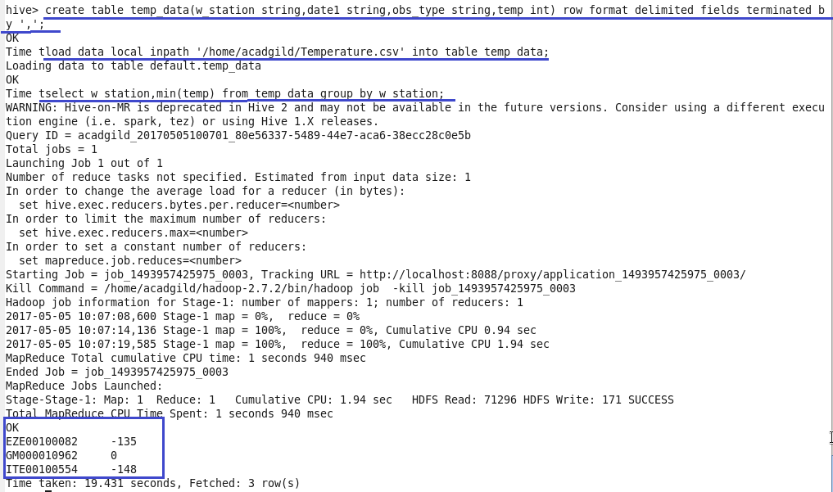

2. Write a hive query to find the maximum temperature observed in a given weather station in a particular year.

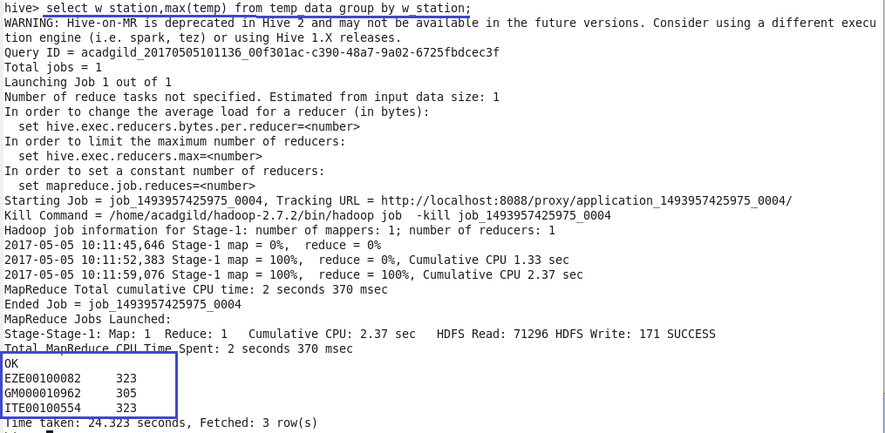

3. Write a hive query to find the number of readings given by each weather station according to the dataset.

